Technical Assessment

Objective - to use python to show case how data are read, manipulated and transformed.

Background

i) Will use the mini app that I created previously to show case - ETL

ii) The mobile mini app will generate the data points (geopoints) that can be use for this case. The app will create the longitude and latitude base on the location of the phone.

iii) The data created dynamically is saved on the cloud ( using Firebase in this case as it is free)

The mini app will stored stored the longitude and latitude into Firebase every 2 mins when activated. Please see the exported data ‘ionic2do-ee1d2-location_2019-07-04-export.json’

e.g. the latitude, longitude and time stamp

"-Lispw78y_rhy1E_qOBq" : {

"lat" : 1.4019449,

"lng" : 103.7510292,

"time" : 1562174275222

},

The data will be transformed into a geojson format that can be read by geopandas e.g.

{ "type" : "FeatureCollection",

"features" : [

{ "type" : "Feature",

"geometry" : {

"type" : "Point",

"coordinates" : [103.7510292, 1.4019449]},

"properties" : {}

},

{ "type" : "Feature",

"geometry" : {

"type" : "LineString",

"coordinates" : [[103.7510292, 1.4019449],[103.7508757,1.4018853]]},

"properties" : {}

},

These data point will be better presented with using a map.

In summary,

The python application will read the created data from the firebase. Transform the data to geojson format. Write the data into a file in a geojson format . Use geopandas to plot and lastly use mplleaflet to show the points and lines in a map. The will allow users to be able to perceive the information better.

1. The language used is python version 2.7.
2. Libraries used are firebase, datatime,geopandas & mplleaflet
3. The firebase db that is storing the data is <https://ionic2do-ee1d2.firebaseio.com>
4. The source file is firebase.json. Before running it, we need to imported all the necessary libraries and dependencies file. In my case, I execute it under jupyter notebook after adding all the dependencies/libraries

Source Codes with Comments wrt to firebase.py file

Lines 1-4 import the required libraries

Line 15-16 uses firebase to read the dataset.

Line 19-20 sort the data according to time it was recorded.

Line 22-67 create the template (geojson) that is recognized by geopandas

Line 69-71 write the output as a file

Line 74 –80 read the geojson file and then plot the points and line and then show the output in a browser.

References

<https://firebase.google.com/>

<https://geojson.org/>

<http://geopandas.org/>

<https://michelleful.github.io/code-blog/2015/07/15/making-maps/>

Using one of the dataset which was created travelling fromYew Tee to Tanjong Pagar. After executing the python application. The below is shown in browser.

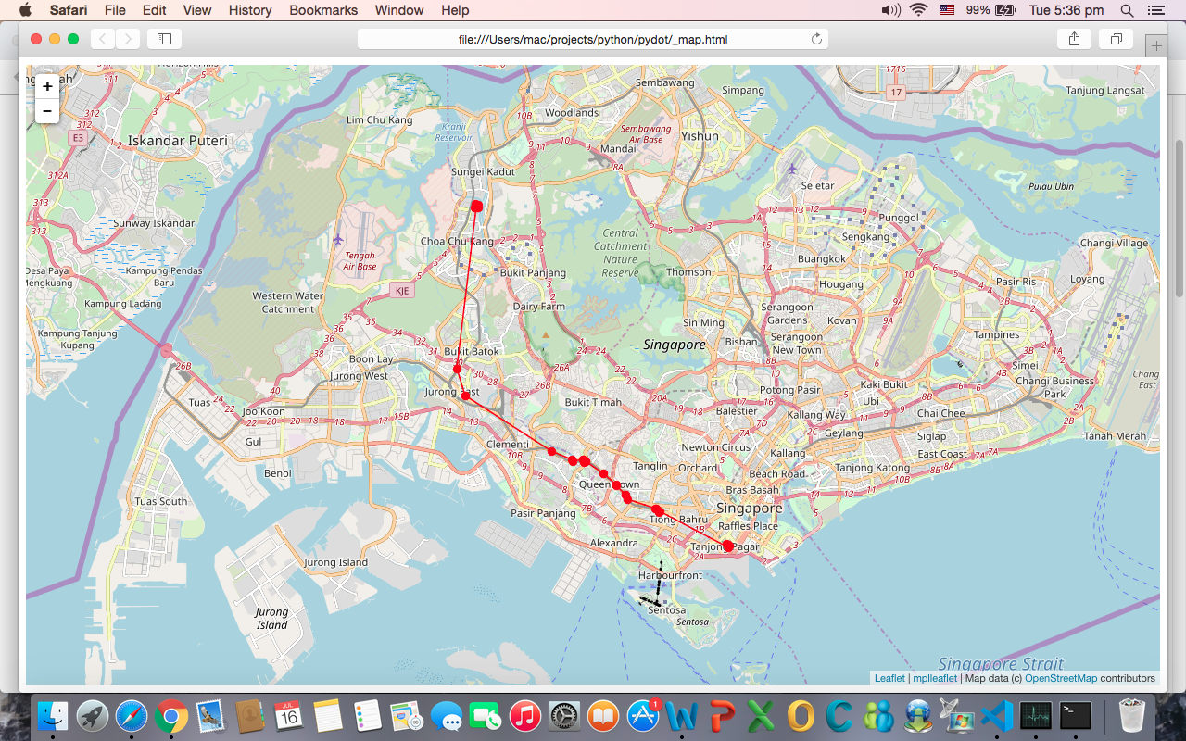

I have uploaded source code and related files to Git.

<https://github.com/soon1238/TechAssessment.git>

which consist of

* firebase.py – which is the application/script that is in focus
* ionic2do-ee1d2-location_2019-07-04-export.json – the exported data set from firebase which we will use for this Tech Assessment
* 2019-07-04.geojson – the tranformed data from json to geojson
* Technical Assessment.docx – which is this file